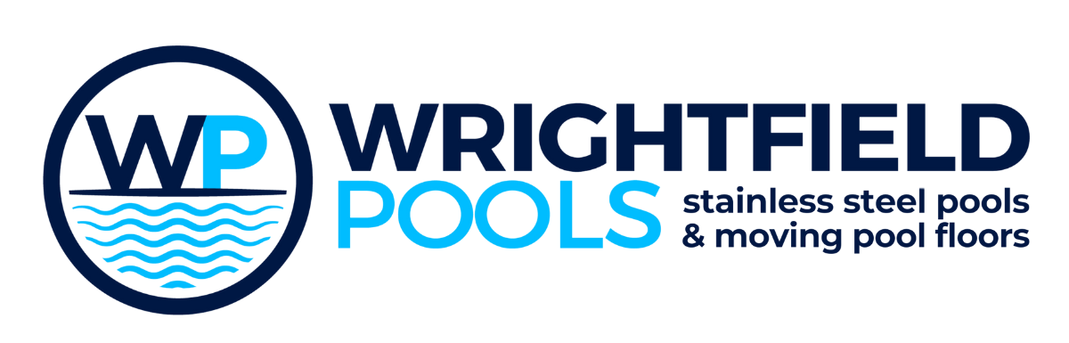

Environmental Standards & Sustainability
Manufacturing Better. Building Responsibly.
At Wrightfield Pools, sustainability is built into the way we design, manufacture and deliver every project. From responsibly sourcing materials through to energy-efficient manufacturing and waste reduction, we continually invest in technologies and processes that minimise our environmental impact while maintaining the exceptional quality our customers expect.
As a UK manufacturer of bespoke stainless steel swimming pools and moving pool floors, we recognise that environmental responsibility extends far beyond the finished product. It begins within our own factory.

Investing in Sustainable Manufacturing
Manufacturing requires energy, but we believe it should be generated as responsibly as possible.
Significant investment has been made across our production facility to reduce reliance on traditional energy sources while improving manufacturing efficiency.
Our initiatives include:
• Extensive roof-mounted solar photovoltaic panels generating renewable electricity
• Heat recovery systems that capture and reuse waste heat from production equipment
• Nitrogen generation technology that eliminates the transport and delivery of bottled gases while reducing emissions associated with logistics
• Energy-efficient fibre laser cutting technology designed to maximise productivity while reducing energy consumption
Together these investments help offset emissions and reduce the environmental impact of manufacturing every Wrightfield Pools product.

Stainless Steel - A Sustainable Material
Stainless steel remains one of the most environmentally responsible construction materials available.
It offers:
- Extremely long service life
- Excellent corrosion resistance
- Minimal maintenance requirements
- 100% recyclability without loss of quality
- Reduced lifetime replacement costs
Unlike many alternative construction materials, stainless steel can be continually recycled into new products while maintaining its original properties.
This contributes towards a genuine circular economy.

Responsible Material Management
Manufacturing inevitably produces offcuts and surplus material.
Our objective is simple:
Nothing that can be reused should be wasted.
Throughout production we carefully segregate:
- Stainless steel
- Aluminium
- Packaging materials
- Cardboard
- Plastics
Steel offcuts are collected and recycled through approved recycling partners, allowing valuable raw materials to re-enter the manufacturing supply chain.
Where possible, material utilisation is optimised during CNC programming to minimise waste before production even begins.

Efficient Manufacturing Processes
Modern manufacturing technology allows us to produce components accurately the first time.
Our in-house capabilities include:
- CNC laser cutting
- CNC folding
- Precision fabrication
- TIG welding
- Mechanical assembly
- Quality inspection
Keeping the majority of manufacturing under one roof reduces transport between subcontractors, improves quality control and significantly lowers the carbon footprint associated with production.

Built to Last
Perhaps the greatest environmental benefit of a Wrightfield Pools installation is longevity.
Every stainless steel pool and moving pool floor is engineered for decades of reliable service.
A longer product lifespan means:
- Fewer replacements
- Lower material consumption
- Reduced maintenance
- Less waste over the lifetime of the installation
Investing in quality from the outset reduces the environmental cost over the entire life of the facility.

Continuous Improvement
Sustainability is an ongoing journey rather than a fixed destination.
We continually review our manufacturing processes, suppliers and technologies to identify opportunities for further reducing our environmental impact while maintaining the engineering excellence that defines Wrightfield Pools.
By combining modern manufacturing techniques with responsible environmental practices, we help our customers invest in facilities that are designed not only to perform exceptionally today, but to remain sustainable for generations to come.

